

**LA MENNAIS SCHOOLS ACADEMIC COMMITTEE**

**BEGINNING OF TERM II EXAMINATIONS**

**ENGLISH READING P.1**

Name:___________________________________________________________________________________

School: _______________________________________________________________Stream__________

**SECTION A**

1. **Match words to pictures**

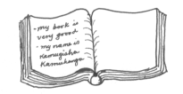 tin

pencil

book

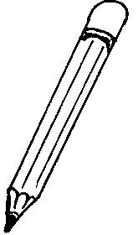

girl

sun

2. **Name the body parts**.

|  |  |  |
| --- | --- | --- |
|  |  |  |
|  |  |  |

(fingers, legs, eyes)

3. **Fill in the missing numbers.**

6 six ______ one

_____ two ______ zero

4. **Write the words correctly**

p-a-t - pat

n-e-t- _________________

s-a-t- _________________

p-i-g- _________________

n-i-t- _________________

5. **Tick words with sound s s s**

sun table cake

church sat pig

lion cat set

6. **Make correct words**

s n- ________________

p i t- ________________

v m- ________________

7. **Count and write the sounds**

t i n = ________________sounds

s h i r t = ________________sounds

b o y = ______________sounds

8. **Write the first sound**

|  |  |  |
| --- | --- | --- |
|  |  |  |
|  |  |  |

9. **Write words for the sounds**

S- ___________________ a- ______________________

t- ___________________ p- ______________________

n- ___________________

10. **Fill in correctly**

My name is __________________________

I am in primary _______________________

My school is _________________________

11. **Read and draw**

|  |  |  |  |
| --- | --- | --- | --- |
| chair | stone | tree | boy |
|  |  |  |  |

12. **Listen and write**

_____________________________ __________________________

_____________________________ __________________________

**Copy and write neatly**

b b b b b

d d d d d

h h h h h

m m m m m

n n n n n

